NAME- Pranit Tandon

REG NO-RA1911028010014

**AIM:-** To Implement vpn configuration using routers in cisco packet tracer

**Component Used**:-

|  |  |  |
| --- | --- | --- |
| Device | Type | Quantity |
| Device | PC | 2 |
| Router | 1841 | 3 |
| Wires | Copper Cross Over | - |

**IP Configuration:-**

|  |  |  |
| --- | --- | --- |
| Device / Interface | Serial 0/0/0 of R2 | Default Gateway |
| PC0 | 1920.168.1.2 | 192.168.1.1 |
| PC1 | 192.168.2.2 | 192.168.2.1 |
| R1  Fa0/0  Fa0/1 | 192.168.1.1  10.0.0.1 | -  - |
| R2  Fa0/0  Fa1/1 | 192.168.2.1  20.0.0.2 | - |
| R3  Fa0/0  Fa0/1 | 10.0.0.2  20.0.0.1 | -  - |

**Circuit Diagram**:-

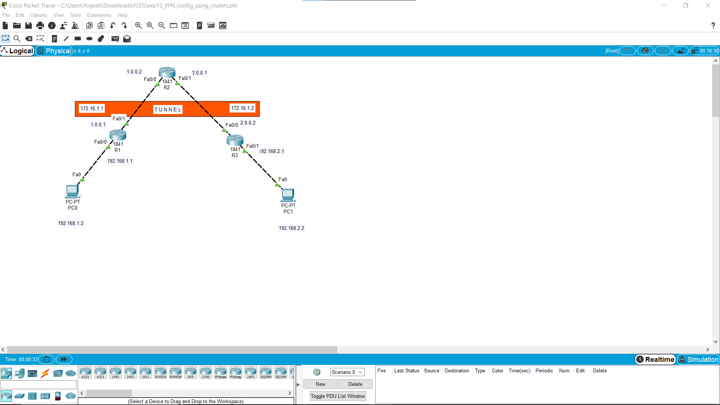

**CLI Configuration:-**

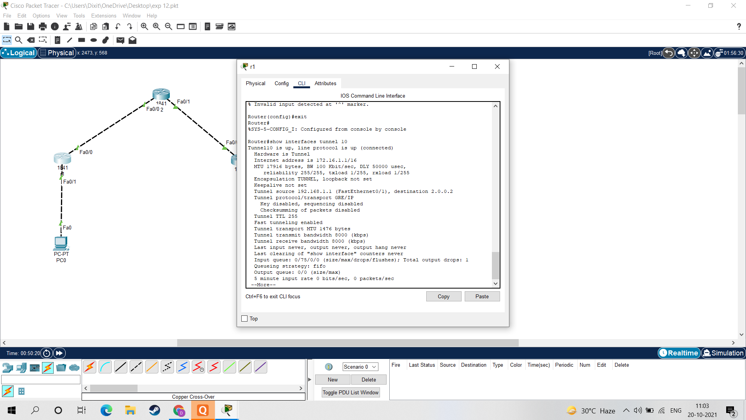

**Ping Command:-**

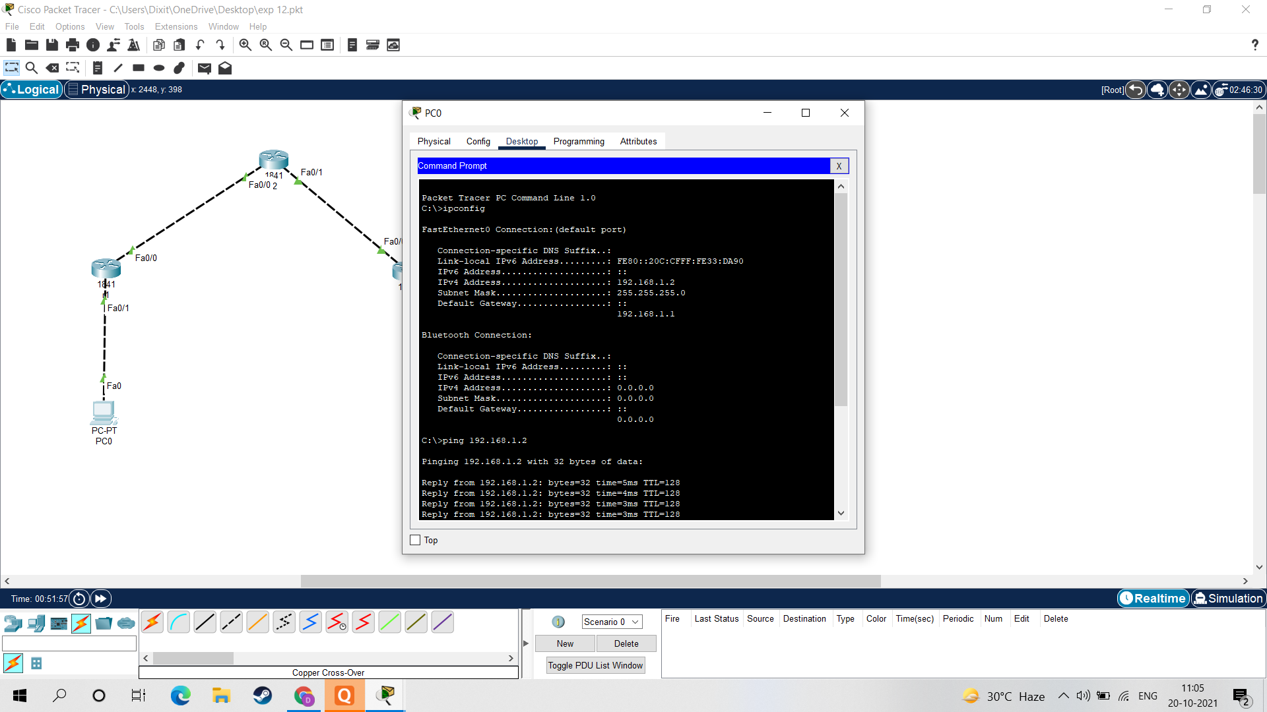

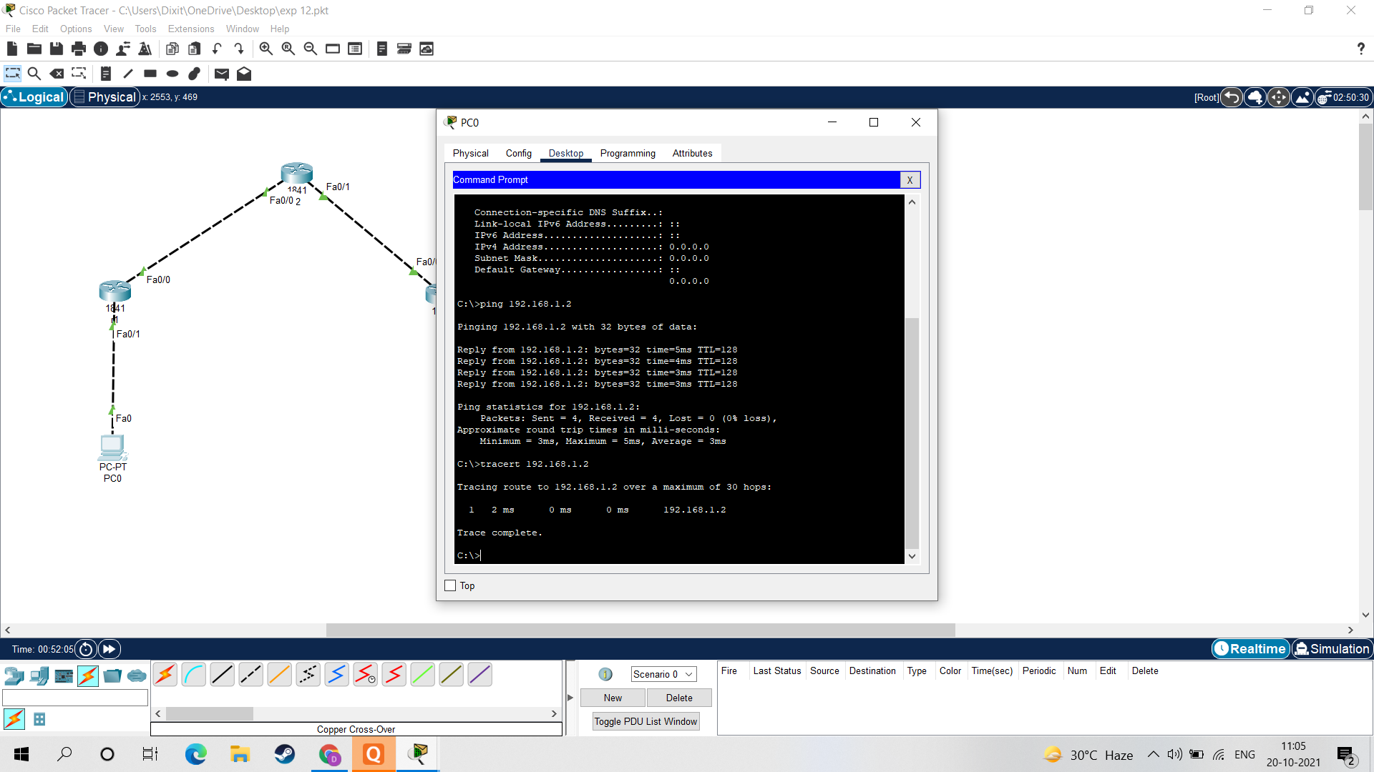

**Result:-**

Hence the VPN configuration is implemented and verified using Ping Command.